|  |  |  |  |  |  |
| --- | --- | --- | --- | --- | --- |
| Date | 23-Nov-22 | | | Tester Name | Mohammad Yusuf |
| Environment | Penfax - Test | | | Login used |  |
| Operating System | Windows | Version: | Update: | | |
| Software Used | Select Software | Version: | Update: | | |
| Select Software | Version: | Update: | | |
| Release version |  | | | | |
| Title |  | | | | |
| Test Type | Regression | | | | |
| Test Scenario |  | | | | |
|  |  | | | | |
| Expected Results |  | | | | |
| Pass/Fail | Select | | | JIRA# | N/A |

Describe your steps with screenshots:

Pre-condition: Login into the application.

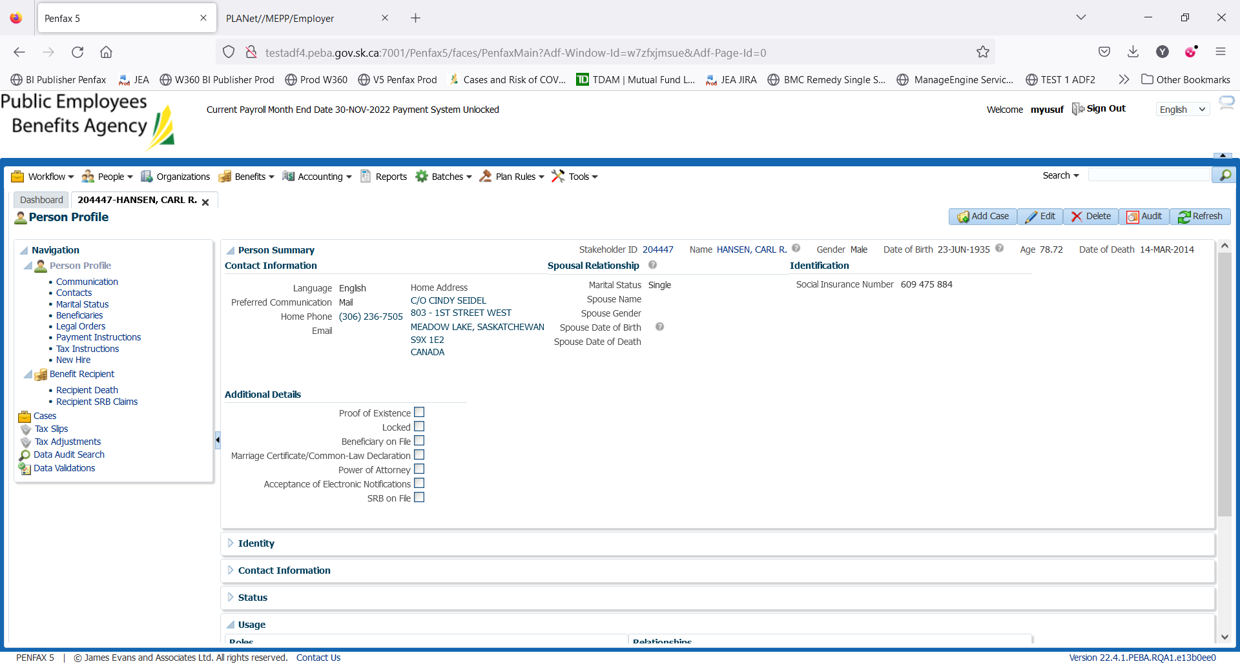

Click on Payment Instructions

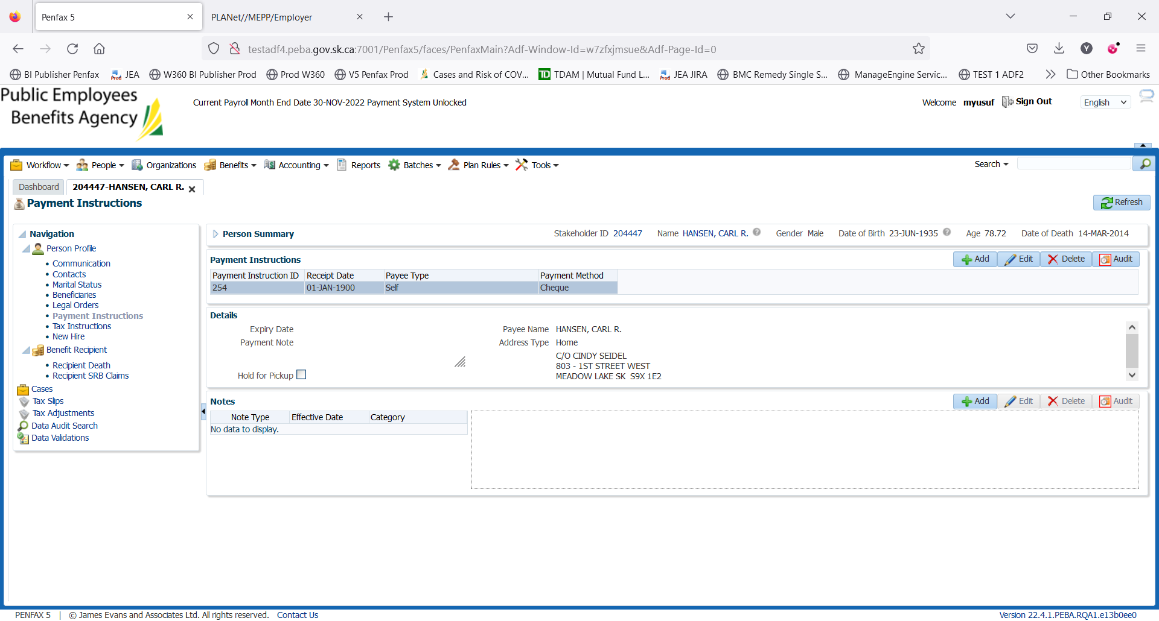

Click on add. New window will pop up.

Select the Payment Method – EFT Canadian

Enter the following details

Bank Number

Transit Number

Account Number

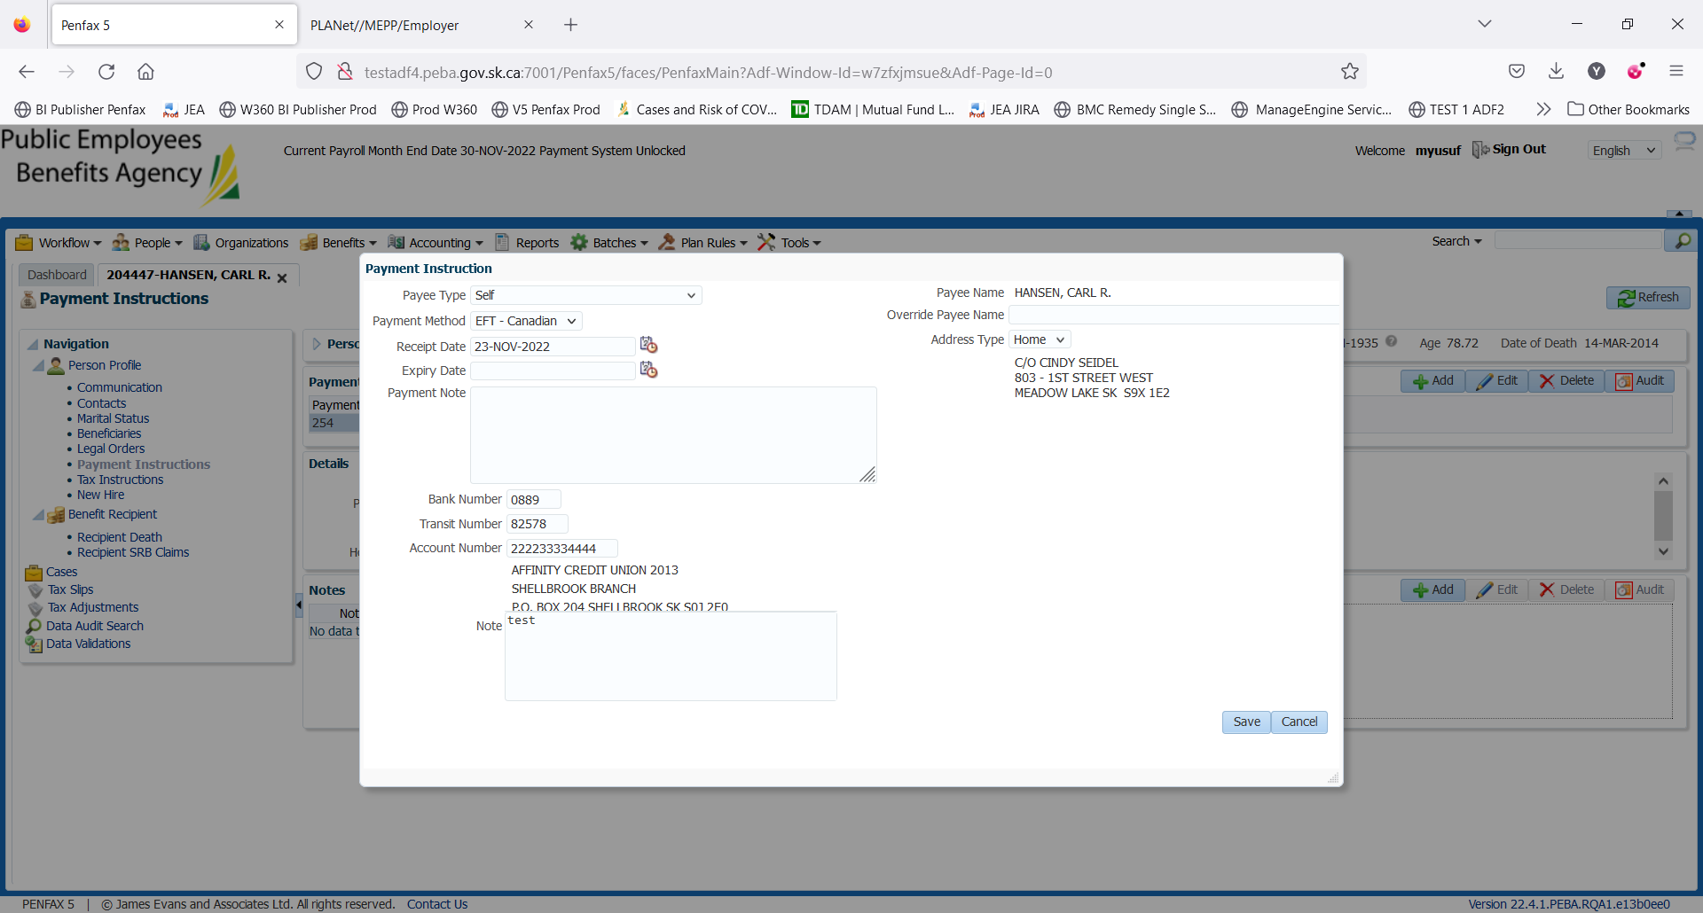

Click Save

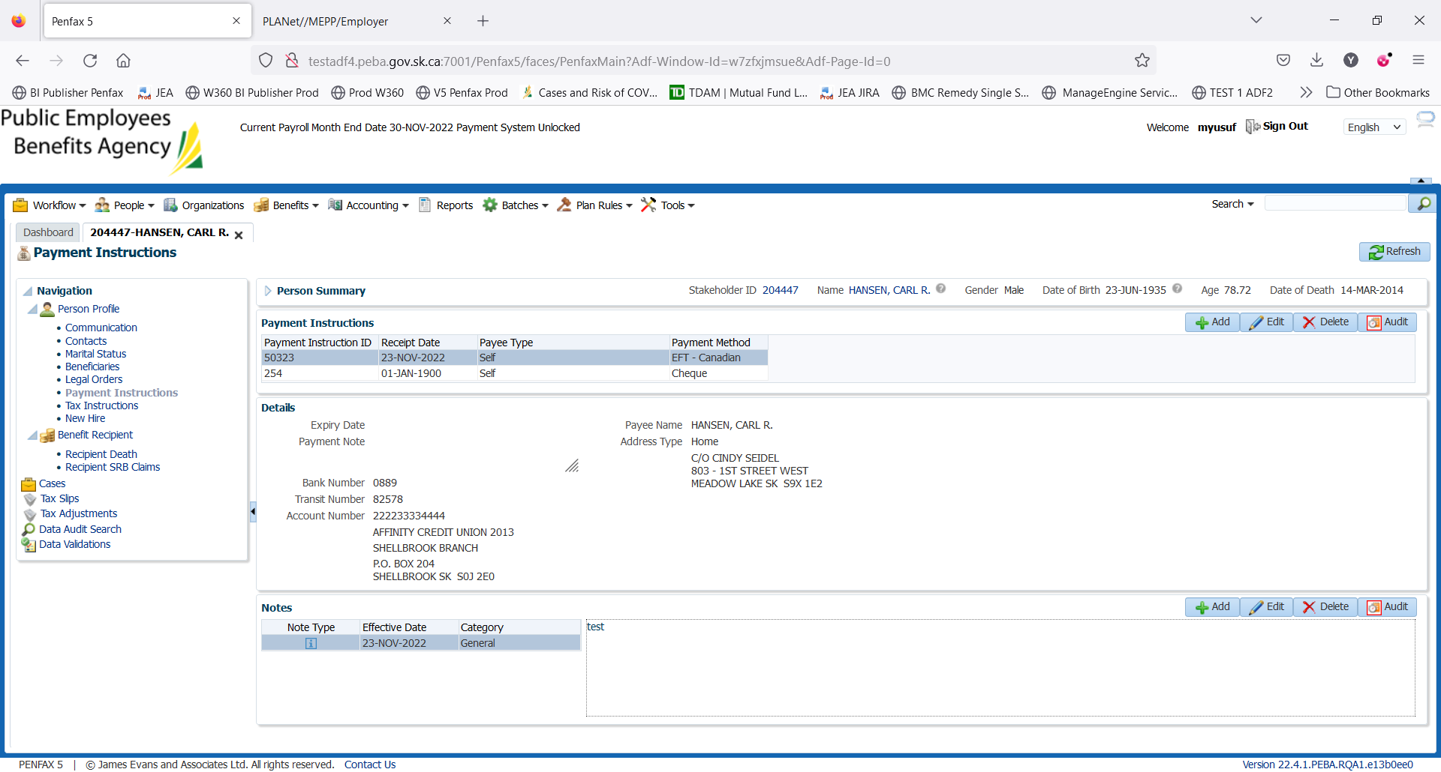

New instructions are added.

Please end the old instructions

Select the old Cheque instructions, click on edit.

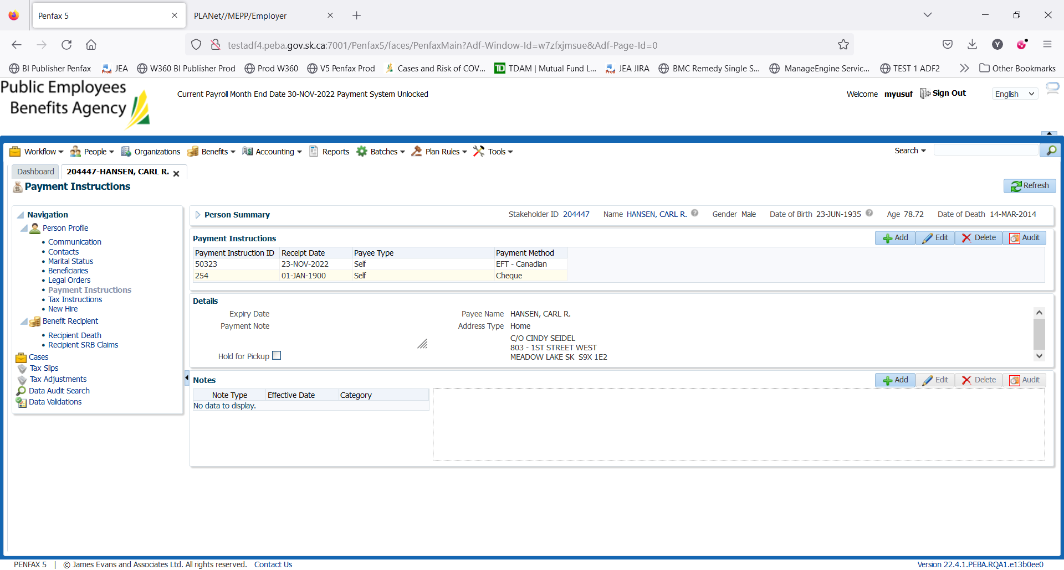

Enter the Expiry date

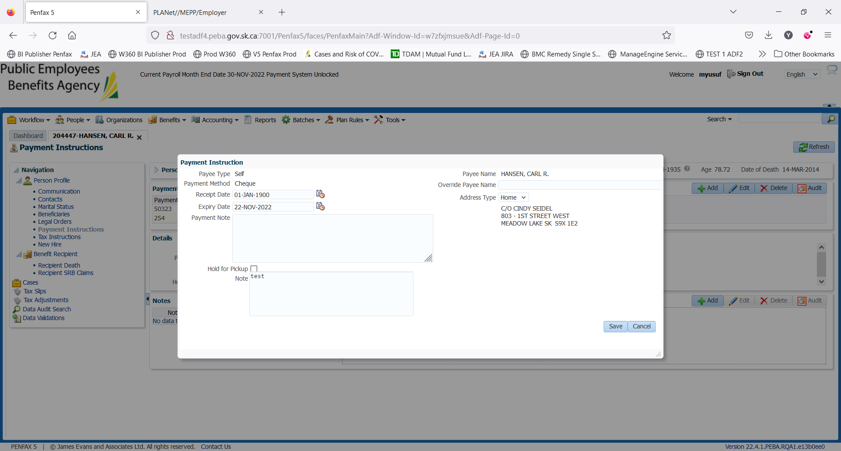

Save it

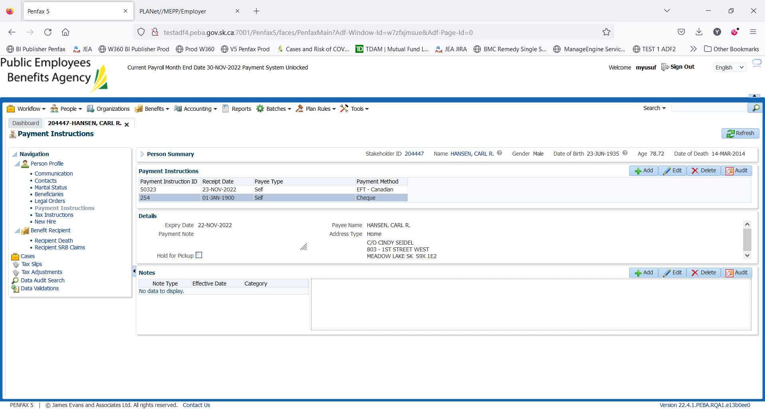

Instructions changed from Cheque to EFT